Copyright reserved

Please turn over

**NATIONAL CERTIFICATE**

**APRIL EXAMINATION**

**MECHANOTECHNICS N4**

**11**

**APRIL 2016**

**This marking guideline consists of**

**9**

**pages.**



**MARKING GUIDELINE**

MARKING GUIDELINE

# QUESTION1

1.1 • Flexibility of layout

* Coordination of services
* Accessibility of service and maintenance points
* Transport routes
* Optimal use of space
* Minimising travelling distances of staff and material
* Minimum handling of material
* One-way flow of material and products
* Pleasant working conditions
* Safety of workers and security of equipment (10 × 1) (10)

1.2 1.2.1 • Viscosity of the paint is too low

* Atomising air pressure is too high
* Distance between the spray gun and the work piece is too great

1.2.2 • Insufficient air pressure

* Blocked pipes reduce paint supply
* Spray nozzle is no longer effective

1.2.3 • Spray gun moves too slow

* Applying too much paint to the surface
* Paint is too thin
* Holding the spray gun too close to the surface (Any 3)

1.2.4 • We use the wrong thinners or solvents.

* We do not mix the paint properly before use.
* The air pressure is wrong.
* We prepare the surface incorrectly.

(Any 3)

(3 × 4) (12)

1.3 • Gravity feed

* Grease lubrication
* Splash lubrication
* Forced lubrication
* Pressure-feed lubrication (Any 3 × 1) (3)

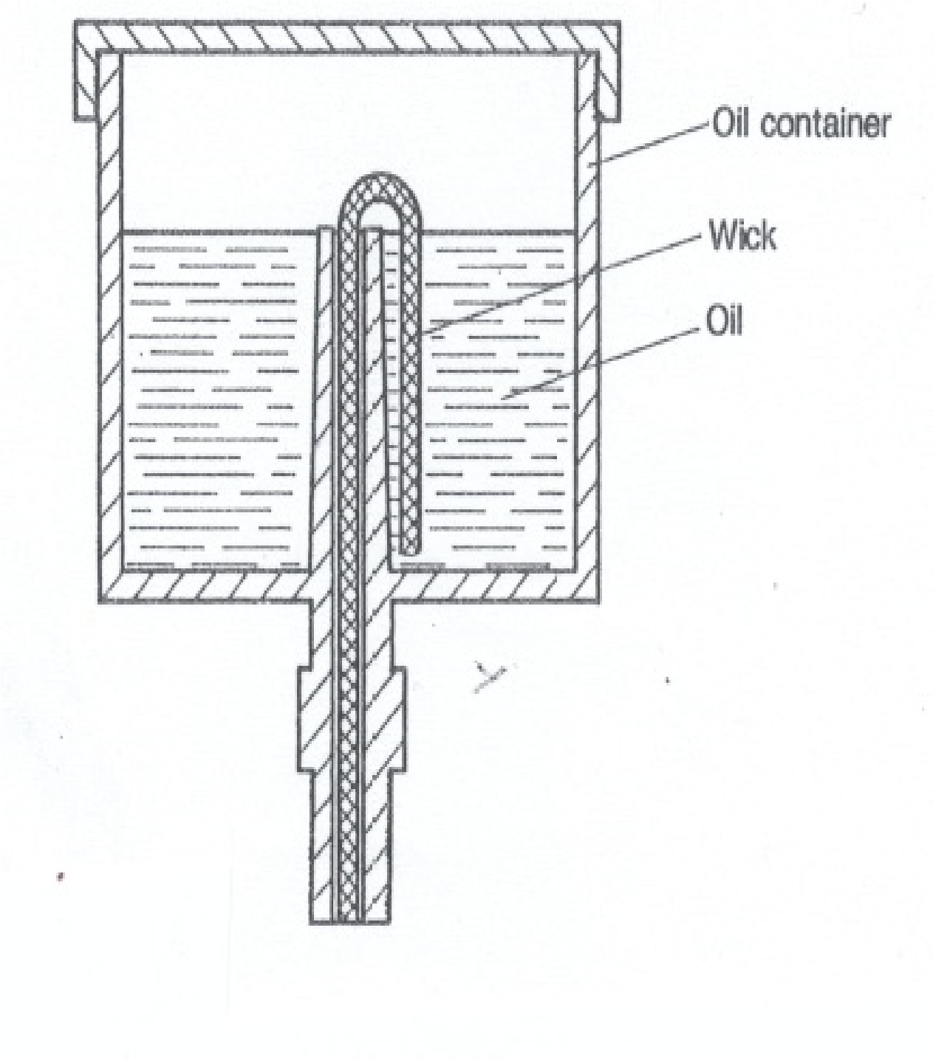1.4

NOTE: TWO marks for the drawing

THREE marks for any three appropriate labels (5)

**[30]**

# QUESTION 2

2.1 (D + t)

V =π N

60

=π´ (1,3+ 0,013)´255 ü

60

=17,53 m/s ü (2)

2.2 TC = Mv2

= 9,75´17,532 ü

= 2996,183 kg/m ü

= 2 996,2 kg/m (2)

2.3 T1 = w ´n´ft

=1´ 4´ 8´1000 ü

= 32 000 N ü (2)

2.4 T1 -TC = e

T2 -TC

32 000 -2 996,2 = e0.2557.3´1720 ü

T2 -2 996,2

29 003,8 = 2,2479(T2 -2 996,2) ü

T2 =15 898,82 N üü (4)

2.5 P = (T1 -T2)V

= (32 000 -15 898,82)´17,53ü

=16101,18 x 17,53 ü

= 282 253,685 W

= 282, 254 KW (2)

2.6 Total power

w =

power per width

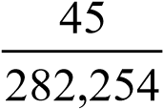 =ü

= 0,15943 mm

=159,43 m ü

= 160 m (2)

**[10]**

# QUESTION 3

3.1 Ff =μmg

= 0,3´150´9,81

= 441,45 N ü

work done = Force ´ Distance

= 441,45 ´ 0,15 ü

= 66,218 J ü (3)

3.2 Work done =175-66,218

= 108,783 J ü

Force = Work done

Distance

= 108,783 ü

0,15

= 725,213 N ü  (3)

3.3 725.213 N ü 2000 N

A

B

7

5

6

5

6

5

ü

Calculate A, Take moments about point B:

CWN = ACWN

A´130 = 2 000´65+ 725,213´205 ü

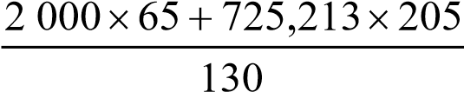 A =ü

= 2143,605 N ü

Calculate B, Take moments about A

CWN = ACWN

2 000´65 = 725,213´75+ B´130 ü

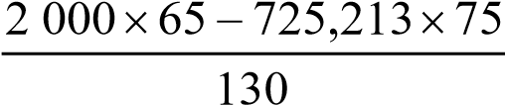

B =ü

= 581,6079 N ü

ALTERNATIVE METHOD:

Upwards = Downwards

A+B = 725,213 + 2 000

2 143,605 + B = 2 725,213

B = 2 725,213 – 2 143,605

B = 581,608 N (8)

# [14] QUESTION 4

4.1 Micrometer reading:

d = 0,577 p ü

= 0,577´3,5 ü

= 2,02 mm ü

w = D+3 d+1,516 p

= 30 +3´2,02+1,516´3,5 ü

= 41,366 mm ü (5)

4.2 4.2.1 • Calculate the chord height

* + Set the vertical scale of the gear tooth vernier calliper
  + Measure the chord width and compare it
  + Compare the chord width with the calculation and measure it (4)

4.2.2

h = mçæ1- π sinθcosθ÷ö ü

è 4 ø

=10´çæ1- π sin200cos200 ö÷ ü

è 4 ø

= 7,476 mm ü

w = πm cos2θ

2

= π´10 cos2200 ü

2

= 13,872 mm ü (5)

# [14] QUESTION 5

5.1 5.1.1 TA

VR=

TB

=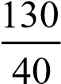

= 3,25 ü (1)

5.1.2 TA TB

VR = ´

TB TC

=-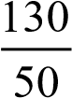

=-2,6 ü (1)

5.1.3 y = 50 ü

x + y = 0

x =-y

=-50 ü

NC =-2,6x + y

=-2,6´(-50)+ 50 ü

=180 r/min ü

Nc rotates 180 r/min in the clockwise/positive direction (4)

5.1.4 y = 50

-2,6x +50 = 0 ü x =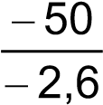

=19,231 ü

NA = x + y

=19,231+50 ü

= 69,231 r/min ü

Nc rotates 69,23 r/min in the clockwise/positive direction (4)

5.2 5

TB = TA

3

=´30 ü

= 50 teethü

PCDA = m´TA

= 6´30

=180 mm ü

PCDB = m´TB

= 6´50

= 300 mm ü (4)

**[14]**

# QUESTION 6

6.1

A = πD2

4

π´0,22

=

4

= 0,031 m2 ü

*m*2 = *Dd*44

0,24

= 0,134

= 5,59 ü

h =12,6 L

=12,6´0,88

=11,09 m ü

Q = Cd ´A´ m22gh-1 ü

= 0,97 ´ 0,031´ 2 ´ 95,,8159´-111 ,09 ü

= 0,207 m3s-1 ü

= 207 Ls-1 ü (7)

MARKING GUIDELINE

MECHANOTECHNICS N4

6.2 πD2

A1 =

4

= π´0,22

4

= 0,0314 m2 ü

πD2

A2 =

4

π´0,42

=

4

= 0,1256 m2 ü

Q1 = Q2

V2 = A1 ´V1 A2

= 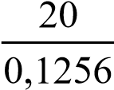´0,0314

= 5 ms-1 ü

P1 + V12 + h1 = P2 + V22 + h2 Rh0 ´g 2g Rh0 ´g 2g ü ü

16´103 + 202 + 0 = P2 + 52 +1,274

1000´9,81 2´9,81 1000´9,81 2´9,81

1,631+ 20,387 =102´10-6 P2 +1,274

P2 =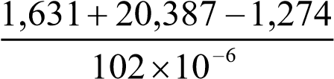 ü

= 203 284,314 Pa ü

= 203,284 kPa (7)

**[14]**

# TOTAL: 100